Advanced Algebra Name: _______________________
Worksheet 6.2 day 4 Period: ______

For problems 1 – 15, fill in the blanks describing the end behavior.
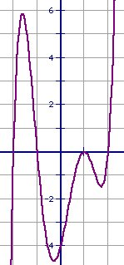
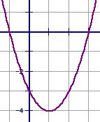
1. 2.

f(x)____ as x- and f(x)____ as x- and
f(x)____ as x+ f(x)____ as x+

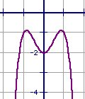
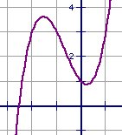
3. 4.

f(x)____ as x- and f(x)____ as x- and
f(x)____ as x+ f(x)____ as x+

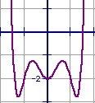
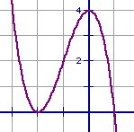
5. 6.

f(x)____ as x- and f(x)____ as x- and
f(x)____ as x+ f(x)____ as x+

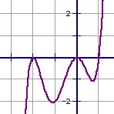
7. 8.
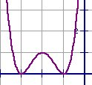

f(x)____ as x- and f(x)____ as x- and
f(x)____ as x+ f(x)____ as x+

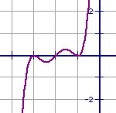
9. 10.
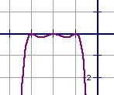

f(x)____ as x- and f(x)____ as x- and
f(x)____ as x+ f(x)____ as x+

Describe the end behavior of the graph of the polynomial function by completing these statements: f(x) → ____ as x → - and f(x) → ____ as x → + .

11. f(x) = -5x⁴ 12. f(x) = 2x

13. f(x) = -3x⁵ – 4x² + 3 14. f(x) = 3x⁶ – x – 4

15. f(x) = -x⁶ + 2x³ – x 16. f(x) = x⁴ – 5x³ + x – 1

